CpowerLED software Instructions

CpowerLED Applicable scope: All C-Power series network version controller
CpowerLED is the latest Lumen Android operating system software which installed on your phone or tablet (Android), phone or tablet connected C-power series network controller by WIFI, and control it by WIFI.

Connection method：Network controller connects to a wireless router; phone or tablet also connects to the wireless router via wireless WIFI, as follows:

Wireless Router
Phone or tablet
CpowerLED
Net controller
Cableee
WIFI

Software features: 1. Play program (single and multi-program play), the number of programs to support is: 1-255
2. Time setting and reading
Note: we will continue to add new features in the future.

一、Software download and installation methods:
Download on our company website, sent to the phone or tablet, select "CpowerLED. Apk" install.

After software is installed successfully, the icon on the screen is “”

二、Control methods:
1、Communication settings: After opening the software, select the screen "Communication" option, set the correct IP, port and Identifier (IDCode), click "OK" prompt "connected" describes communication is normal, as shown below
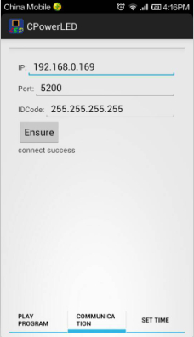

2、Play program：Select the screen "Play Program" option, enter the play program features interface, as shown below
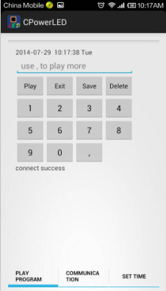
1）、single program play, for example:1+play，screen play “program 1”
2）、multi-program play, for example:1, 2, 5, 9+play, screen replay “program 1, program 2, program 5, program 9”
3）、Click "Exit": Exit play program feature, back to all schedule programs replay.
4）、Click "Save": The selected program information saved to the flash, keep it when power off.
5）、Click "Delete": Deletes the selected program number, reselect new programs

3、Time setting and reading: Select the screen "Set Time" option; enter the time setting and reading interface, as shown below
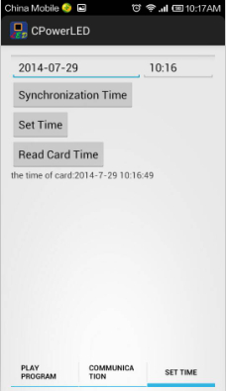

1）、Synchronization time: Time synchronization with mobile phone
2）、Set time: Set mobile phone time or manual input time to control card
3）、Read time: Read control card current time

